**Internet of Connected Devices**

Final Report

C40: Ryan Clulo, Franco Reda, Zhou Shen, Sam Norris

**Sponsor**: Direct Supply

**Sponsor Advisor**: Kent Newbury

**Advisor**: Dr. Richard Povinelli

May 4, 2018

Table of Contents

**Project Design Summary** **3**

Executive Summary 3

Project Background 4

Project Definition and Purpose 4

**Final Design Description and Justification** **5**

Customer Needs Validation 5

Sponsor Requirement Checklist 7

Software Justification 8

Prototype Delivery 9

Experimental Verification 9

Results and Conclusions 9

**Machine Learning Results and Pulse Oximetry Analysis** **9**

Weka Results 9

Kaggle Results 9

Pulse Oximetry for Predicting External Factors 9

**Economic Analysis** **9**

Materials, Components, and Production Costs 9

Development and Maintenance Costs 9

Total Cost and Sales Forecast 10

**Risk Analysis and Regulatory Information** **11**

Risk Analysis 11

Applicable Standards 11

Regulatory Issues 11

Legal Issues 11

**Project Legacy** **11**

Internet of Things in Home Health Care Applications 11

Applying Machine Learning to Home Health 11

Conclusion 11

**References** **11**

**Appendices** **11**

# 

# Project Design Summary

## Executive Summary

Over the course of the year, the C40 design team explored the application of internet of things networking and machine learning within the home health care space. Direct Supply sponsored the project in an effort to gain a better understanding of how recent advances in the computer science field can make healthcare more personal, timely, and cost effective. The result of the project is an embedded smart hub that networks small medical sensors via bluetooth, capable of collecting and displaying the results. In addition, the system applies machine learning to the collected data to provide instantaneous analysis and flagging of abnormalities for further investigation by a medical professional.

The team worked very hard over the year to meet the specified customer needs. We chose to focus particularly on the connection with the pulse oximeter device as it proved to be the most easily understandable packet structure from the previous C40 project. The project was broken into two distinct phases: implementing bluetooth networking to communicate with the pulse oximeter, and applying machine learning to pulse oximeter readings.

Immediate challenges to connecting the Raspberry Pi to the pulse oximeter via Bluetooth 4.0 Low Energy mode came from interpreting the protocol document specified for the pulse oximeter. Knowing that developing and implementing a full Bluetooth stack was beyond the scope of the project, the team attempted to script the interaction using BluePy and Gatttool while monitoring packets using a Bluetooth sniffer. While connection between the devices was achieved, they did not properly exchange information. The team realized that the developers of the pulse oximeter had modified the GATT protocol to add a cryptographic check specific to the device’s serial number. With help from a local company Onkol (partnered with Direct Supply), the team was able to develop a solution designed for the Android operating system. Seeing the power of OS specific tools for Bluetooth in Android, the team made the switch locating an Android kernel for the Raspberry Pi.

In parallel to developing the connection protocol, the team began researching the characteristics of the data the pulse oximeter provided: pulse rate, and blood oxygen content. The data the team acquired to research the application of these metrics came from the Physionet [14] waveform database and is from a 2017 study on patterns in variability of blood oxygen saturation (SpO2) in aging populations [13]. The team applied various decision trees and linear regression models based around the nominal and statistically generated variables from the study. The team used Weka, a collection of tools from the University of Waikato to evaluate the data [15] as well as Kaggle’s online machine learning functionality.

The project represents mixed success. From our broad efforts in BLE networking, our team is able to make suggestions to Direct Supply about using the Android platform along with Android family hardware to design the embedded system and can supply working code developed in partnership with Onkol. Future design teams in this field will have a strong foundation environment to move forward in with obvious avenues for necessary education. We are also able to provide the results of our study on blood oxygen variability and the usefulness of this metric in determining health factors through machine learning on the device.

## Project Background

Medical devices are changing every aspect of healthcare. From diagnosis to treatment, these devices provide essential information, but handling all the data can be a challenging chore that distracts doctors, nurses, and caregivers from treating the patient. Direct Supply would like to remove obstacles by gathering all information together via an internet of connected devices where the data is processed and ready for analysis in real time. Simplification of the system and operator time savings will lead to smooth interactions between caregiver and patient, the best, most accurate treatment, and cost reduction through increases in productivity. Applying machine learning will allow doctors to gain even greater insights from patient data and flag complications even before they are noted by professionals.

## Project Definition and Purpose

The purpose of the project was to build an interface between a clinical measurement device and a small data collector used to save and store readings from the device. Direct Supply wanted to understand the technical complexities involved in building a small embedded-computer product that collects data from an Internet of Things (IoT) connected clinical device. Additionally, Direct Supply wants to understand factors that influence clinical readings. This information will be used to develop further experiments that can lead to better living environments for elderly individuals. The data that is collected is be analyzed for trends through machine learning.

The project focused on improving the connection mechanism between the pulse oximeter (a device that records pulse rate and O2 levels of a test subject) via Bluetooth in order to do real time analysis as well as develop an algorithm to understand if there is any correlation between age, time-of-day, mood, and stress levels and the readings taken with the pulse oximeter.

Building on the previous C-40 project, the team chose to continue to use the Raspberry Pi for our embedded system. However, the the team implemented the solution with a switch to the Android operating system for better OS support of similar devices. This change maintains the ability to support future delivery of the solution as a small embedded controller. Using this system, we developed an application framework to combine data acquisition through BLE and visualization.

Testing and verification included thorough analysis of the technical portion of the project and human factors influencing readings. The technical portion includes the hardware systems, the methods of connecting devices, the database structure, and accuracy of visualization. Testing also required research into the relationship between the listed health and human factors and pulse oximeter readings. With the information we have gathered, we will provide insights for Direct Supply for improving connected medical devices across a variety of uses.

The customers of this technology are primarily medical facilities, hospitals, and nursing homes. While our product was not designed specifically for the home environment, trends in this field are to move care closer to the patient where it is less invasive and expensive. The IoT solution coupled with machine learning will become commonplace in the future. Direct Supply is the leading provider of equipment and solutions to help enhance Senior Living environment and operations and as such, we focused on adapting devices most useful to this space.The clients in this space are patients whose medical care will benefit from connected systems. Important factors for them will be better individual health care mostly focused on comfort, accurate analysis and testing, treatment, and protection of private medical data.

# Final Design Description and Justification

## Customer Needs Validation

Customer needs are broken into three project components: the hardware, specifically the embedded IoT system and the pulse oximeter, the software in the form of an Android app that maintains a connection, retrieves data, and displays it, and the machine learning study of pulse oximetry that analyzes the usefulness of the information. The final hardware prototype includes a connected clinical IoT device in the form of a Raspberry Pi that interfaces with a Direct Supply pulse oximeter via bluetooth. All primary hardware components are listed in table 2.1.1. The pulse oximeter records and transmit the pulse rate and blood O2 levels of a patient back to the the Android device (Raspberry Pi system) for processing. It is intended that the Raspberry Pi display all transmitted information on the 7” display but incompatibility with the Bluetooth chip and the Emteria Android system on the Pi has limited this functionality though it has been verified in other testing in simulation and on different hardware. Along with the current pulse and blood O2 level, we show current external factors that may influence the readings.

|  |
| --- |
| **Hardware** |
| Raspberry Pi 3(with preinstalled OS) |
| Raspberry Pi 7” Touchscreen Display |
| Case for Raspberry Pi 7” Display |
| Direct Supply Pulse Oximeter |

Table 2.1.1 - Lists of purchased hardware for project

The software supports Bluetooth connections with the Pulse Oximeter and executes the necessary messaging between the computer system and the Pulse Oximeter to obtain readings. It does not currently store the readings in a database.

The team conducted an experiment for analyzing the relationship between the readings that are taken and factors that could influence the readings. Weka and Kaggle analysis ran separately from the Raspberry Pi that processed the data providing insights on the correlation between age, smoking history, and BMI and data acquired from pulse oximetry. These programs have the potential to evaluate large samples of data using machine learning generating regressions and decision trees to classify different characteristics. These are not intended to be run in real time and there are no constraints on processor power or execution time. This machine learning portion of the project is one of the most important deliverables for direct supply as they are currently building a full IoT solution for connected devices in parallel with ours. While they may or may not implement our prototype particularly the hardware or display software, they are very interested in early analysis of health related issues that can be gained by efficient use of the connected system. Our analysis in Weka and Kaggle are of great interest to jump starting this work.

Verification included thoroughly testing the IoT connectivity between the pulse oximeter and the Raspberry Pi. The connection must be robust and secure as it will be transmitting sensitive patient information. In addition to verifying the hardware, we tested the machine analysis thoroughly for small cases before and designed with tools that can be applied to large samples of data.

## Sponsor Requirement Checklist

The sponsor requirements are listed in table 2.2.1. The team successfully worked within the budget to create the final prototype. The team made the design choices required in needs 2 and 3 implementing the system on the Raspberry Pi. The 3rd requirement is not not fully met as compatibility issues between the stable version of Android for the Pi had issues accessing the Bluetooth chip resulting in lack of functionality of the app. The team verified the functionality both in simulation and on other Android hardware. Requirement 4 became significantly more complicated to develop when the team switched to the Android system. The team designed and conducted a machine learning experiment as required in requirement 5. Specific statistically significant problems with the data analyzed leaves more work to be done for requirement 6.

|  |  |  |  |
| --- | --- | --- | --- |
|  | **Customer Need** | **Met?** | **Comment** |
| 1 | The budget for the project will be $500 to cover expenses for the computer system that the students select. Direct Supply will reimburse costs for equipment and software up to that amount. | 100% | The team met the budget for the project. The total cost of development was $52.21 for a Bluetooth sniffer, SD storage for the switch to the Android OS, and batteries for the pulse oximeter. |
| 2 | The student team will be responsible for selecting the computer system to be used, configuring it with an operating system, and installing or writing any software needed for the project. | 100% | The team selected to continue with the Raspberry Pi as it is a standard for embedded devices. The team switched from Raspbian to Android for better support. In partnership with Onkol, the team developed an app that connects the devices and displays readings. |
| 3 | In order to fully understand the complexities of developing interfaces to connected clinical devices, the student team will be expected to write software that supports Bluetooth | 75% | All software is fully capable of supporting Bluetooth including the app and the Android OS. There are complications and incompatibilities between the Android Kernel and the Bluetooth chip on the Raspberry Pi resulting in problems deploying the app on the Pi hardware. |
| 4 | Connections with the Pulse Oximeter, executes the necessary messaging between the computer system and the Pulse Oximeter to obtain readings, and stores the readings in a database. | 50% | The system properly manages the connection between the system and pulse oximeter but does not store the readings in a database. |
| 5 | The student team will need to design an experiment for analyzing the relationship between the readings that are taken and factors that could influence the readings. | 100% | The team analyzed the pulse oximetry determining that there is minimal correlation between external factors. Healthy pulse oximetry falls within narrow windows and as such, analysis of healthy data is not useful. |
| 6 | The student team will need to take enough readings to support analysis in relation to factors that could influence the readings. Analysis of the readings can be done off device | 70% | The team concluded that readings taken locally would not meet the requirements for the project. As such, they located readings in the Physionet database. The team conducted the experiment using machine learning on personal computers. |

Table 2.2.1 - List of Sponsor Requirements and Progress

## Software Justification

We began the project working with Raspbian OS on the Raspberry Pi and had some early success using Gatttool to make connections with our Raspberry Pi, however as stated in our executive summary we ran into issues acquiring the attribute data from the Pulse Oximeter via this method. The team reached out to local company, Onkol for advice. The recommendation given to us by Onkol was to switch to an Android development environment. Additionally, the team was able to meet with an engineer from Onkol who was able to give us some much needed guidance on Android app development as well as some sample code for us to modify.

The team remained committed to the creation of an embedded system, so we investigated implementing an Android kernel on the Raspberry Pi. *Running Android on a Raspberry Pi 3* provided the necessary information to install the operating system. Flashing the Kernel was not an issue but the resolution of our touch screen was not compatible with tablet Android and could only be viewed with HDMI connection. A solution to this problem was to use a industrial version of Android called Emteria that came with its own limitations on Bluetooth, an essential component to the project. Ultimately, the team decided to move forward with the development of the android app utilizing a mobile android device as a testing environment.

## Prototype Delivery

The current prototype fully incorporates the code provided to us by Onköl. Figure 2.4.1 shows the working prototype simulated on an Android phone displaying live data from the pulse oximeter. It is capable of finding local BLE devices and displaying them in a list. Figure 2.4.2 shows the device maintaining the connection between the pulse oximeter keeping track of it in a list. The app can successfully pass the cryptographic check that is unique to the Direct Supply pulse oximeter. We were also able to display the data sent from the pulse oximeter. Some features we were ultimately unable to be implemented into our final prototype. The team worked on displaying data from the pulse oximeter as a chart that updated in real time. However, there were several obstacles that prevented us from doing so. The pulse oximeter only sends one packet of data, after which it shuts down. This appears to be a limitation of the functionality of the device, and there is not anything we can do with software to correct it. Additionally, the chart package that we utilized, MPAndroid was not designed for real-time data.

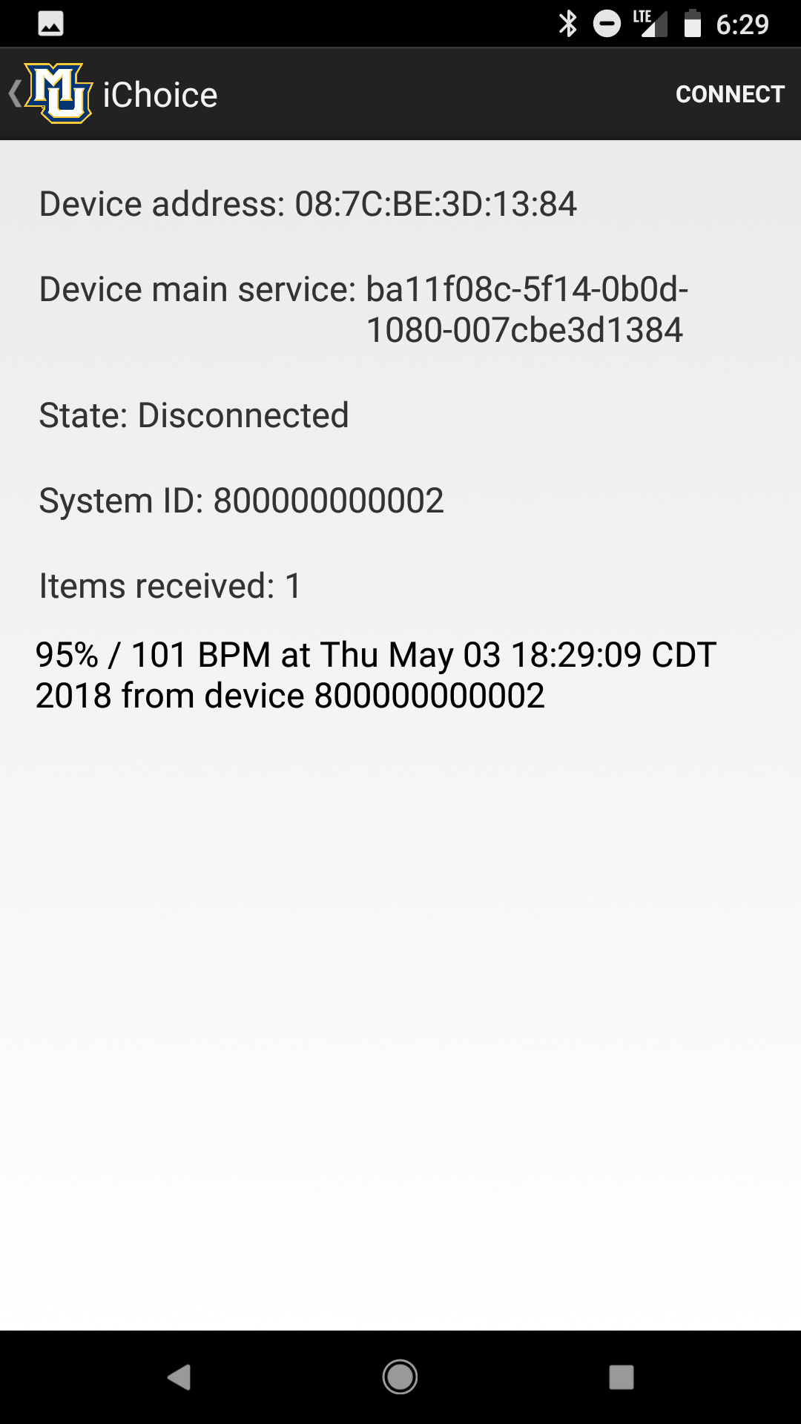

Figure 4.2.1 - Prototype App Demonstrating Data Display

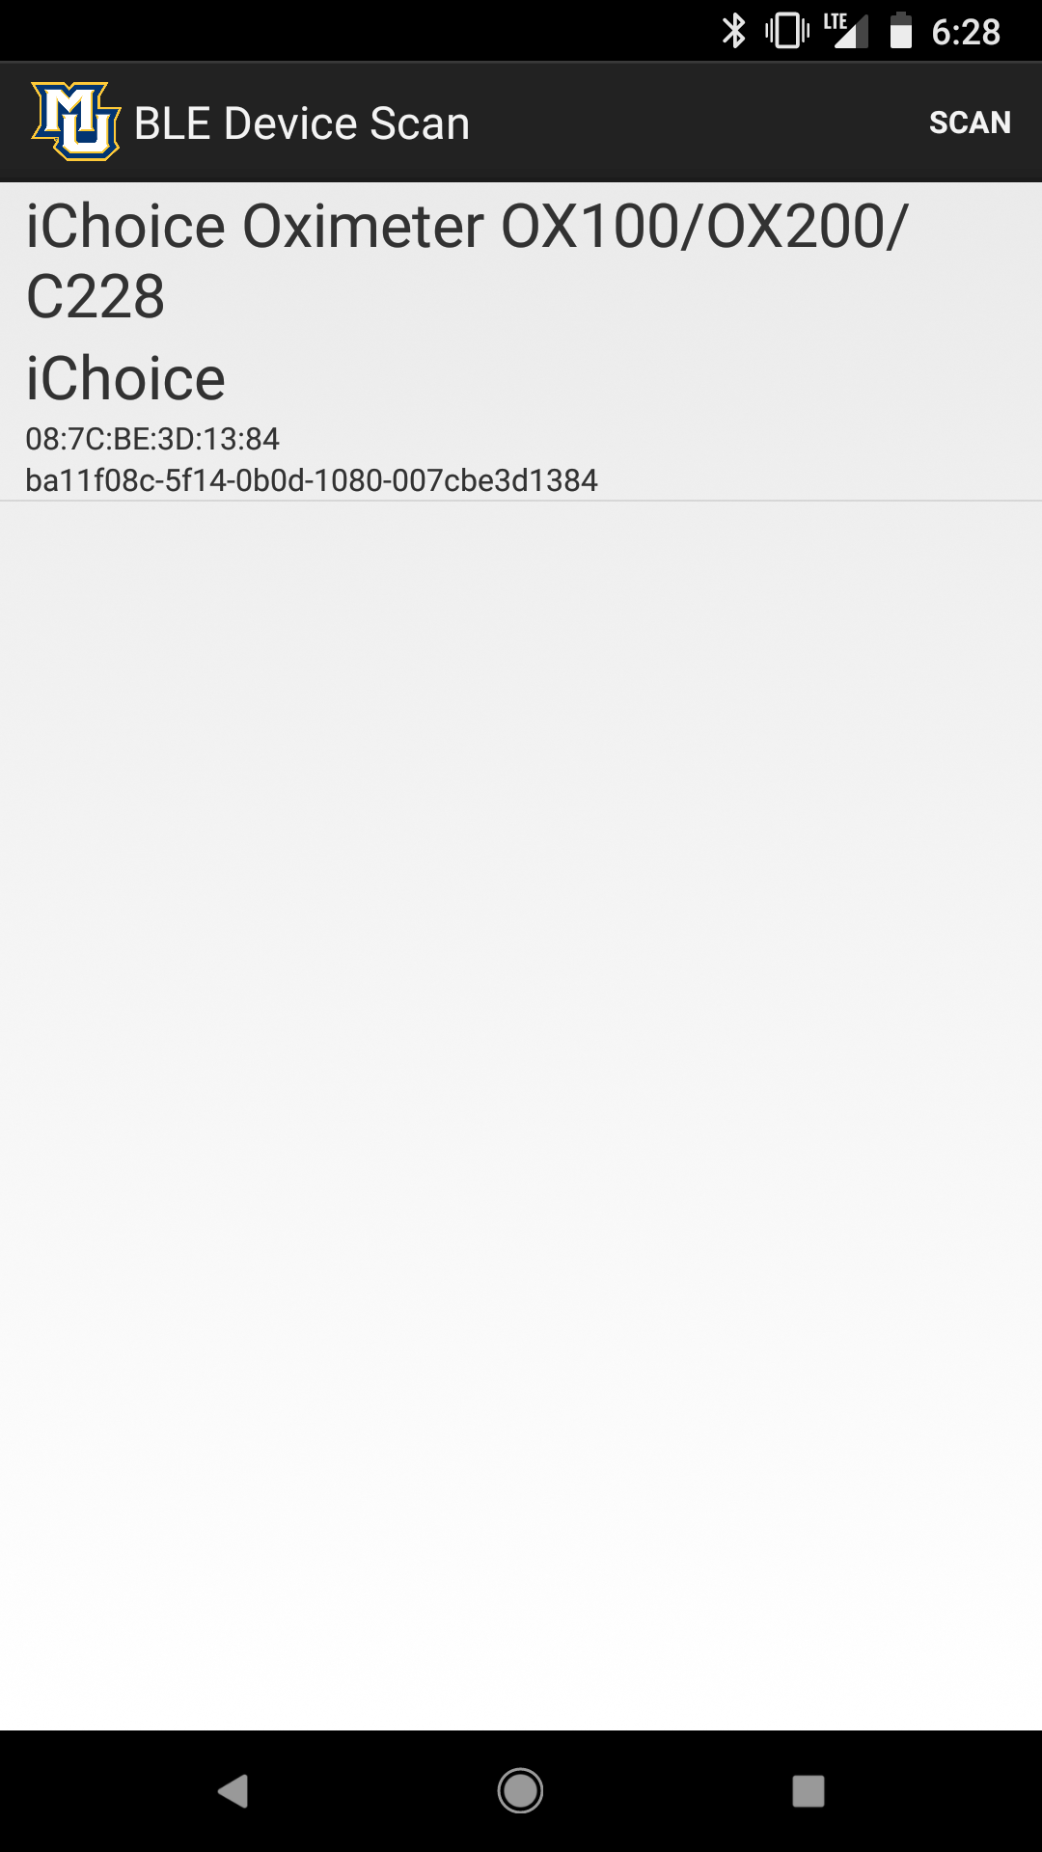

Figure 4.2.2 - Prototype App Demonstrating Connection

## Experimental Verification

The team conducted several experiments to verify the function of the final design particularly relating to the Bluetooth connection and its stability. Accuracy of data transfer was considered high importance and was tested. The team also tested the ability of the app to visualize the data. The purpose of the connection verification experiment detailed in table 2.5.1 is to demonstrate that we can successfully make a connection between the peripheral device and our smart hub on a regular and consistent basis. We conducted the following experiment off the RPi using an Android phone.

**Connection Verification**

|  |  |
| --- | --- |
| **Experimental Procedure** | 1. Start Up C40 Health App on Raspberry Pi 3 Hardware 2. Begin Connection Procedure 3. Observe Connection between Pulse Oximeter and C40 4. Close and reopen app 5. Observe if connection is maintained 6. Repeat steps 1-5 with C40 app running on Android Phone |
| **Equipment** | 1 - Pulse Oximeter  1 - Android Phone  1 - Raspberry Pi Running Android |
| **Results** | We were able to verify that a connection is made and maintained consistently. On occasion the pulse ox is not displayed under the list of available devices. Currently this problem has not been reproducible and we are looking into solving it. |
| **Conclusion** | Our team found that the Bluetooth Low Energy connection is created with a level of regularity to make us believe that a non-connection is an anomaly. |

Table 2.5.1- Connection Verification Experiment

We theorize that by examining the data outputs of two separate pulse oximeters we’ll be able to see whether or not our data collection has an acceptable level of precision.

**Data Transfer Accuracy**

|  |  |
| --- | --- |
| **Experimental Procedure** | 1. Start Up C40 Health App on Raspberry Pi 3 2. Attach Pulse Oximeter to user and start device 3. Pair the device with Health App 4. Observe if values shown on app are consistent with the physical device |
| **Equipment** | 2 - Pulse Oximeters,  1 - Raspberry Pi Running Android |
| **Results** | All data points shown on our app are consistent with what the physical device is reporting. There was not a single faulty data point in our testing. |
| **Conclusion** | The C40 health app currently correctly interprets information it receives from the Pulse Oximeter. Both pulse oximeters showed the same values after a small amount of time, showing that they are precise. No change is needed to the app. |

Table 2.5.2 - Data Transfer Accuracy Experiment

The team verified the visualization capabilities through the following experiment. This experiment will verify that our app creates accurate graphs and visualization, and that these are readable by the user.

**Visualization**

|  |  |
| --- | --- |
| **Experimental Procedure** | 1. Start up C40 Health App on Raspberry Pi 3 2. Attach Pulse Oximeter to user and start device 3. Collect data from pulse oximeter 4. Use app to create visualization 5. Determine whether the visualization accurate represents our data points 6. Show visualizations to third party to gauge readability |
| **Equipment** | 1- Pulse Oximeter  1 - Raspberry Pi Running Android |
| **Results** | This test has not yet been performed as we are still currently implementing visualizations to our application. |
| **Conclusion** | Depending on the results, this test will determine what changes we make to our data visualization. |

Table 2.5.3 - Visualization Verification

## Results and Conclusions

Our hub device will be able to make a consistent and stable connection to the pulse oximeter peripheral over the BLE protocol. The pulse oximeter makes stable connections over BLE with our Android software in independent tests on a seperate phone. The next step in prototyping our smart hub is to load the app onto the RPi and complete testing on this system. Through our tests we’ve been able to find that our pulse oximeters measure pulse and blood oxygen with consistent results. The device will create visualizations of pulse and blood oxygen data over time, and this feature will be implemented soon. The visualizations will need to be effective in portraying the data that the device has collected.

Constraints with the distribution of Android we are running on the RPi have limited full system testing. We have however emulated the app on a phone running Android as a proof of concept for the integral parts of the bluetooth functionality. The particular section we have worked hard to verify through experimentation is the cryptographic check portion of the protocol. The code provided by Onkol creates the basis for us moving forward with writing our own implementation of the protocol drawing heavily from libraries they created that automatically poll the pulse oximeter for specific hardware information necessary to the cryptographic check including the serial number. Similarly, we have referenced Onkol’s implementation of the BLE stack which uses event handlers to capture and maintain pairing between the devices.The experiments listed in the manifest in section 3 demonstrate our success in connecting the devices and implementing the the communication protocol defined for the pulse oximeter. Using this prototype app, we have met the requirements for establishing and maintaining a connection. Using this connection, we have transferred real time pulse oximetry accurately. This demonstrates a successful proof of concept.

Our tests demonstrated that the basic functionality of the app is working as intended. Improvements are going to be made to streamline the experience for consumers. We need to have the connection work as close to 100% of the time as possible, and ideally automatically connect the device after it is paired. This is essential for our older consumers to use our device effectively. Having the required features implemented flawlessly will allow us to add extra components to further improve the app in the future.

# Machine Learning Results and Pulse Oximetry Analysis

## Statistical Analysis

The team broke analysing data part into two parts: acquiring data and managing data. Because our data involves sensitive and private information like patients’ age and smoking status, the team tried to find a website that provides the pulse information of anonymous patients. Our advisor, Dr. Povinelli, suggested a website called physionet which has a variety of healthcare related datasets [17]. The team did some research and found a dataset for pulse oximetry which fit the needs for our project.

After download the data information, the team tried to classify the data. Because there are bunch of data during a long time and we knew that advantage of variance is good for measuring, the team calculated the variance for pulse data for each individual. The team tried three ways for analysing data: excel, Weka and Python. Excel is a good tool for the team to check the relationship between variance of pulse data and factors if the team made some graphs but there are also obvious disadvantages: we cannot use decision tree, do feature engineering or predict the result. Therefore, the team were divided into two group for using different effective tools. Figure 3.1.1 shows our primary analysis of the correlation between attributes in the data.

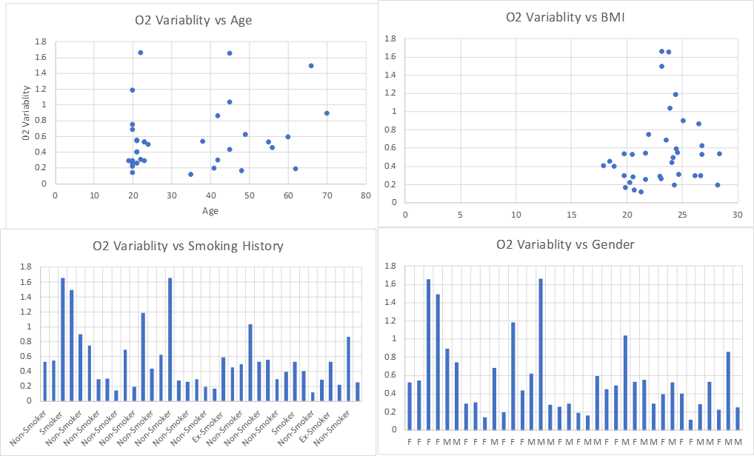

Figure 3.1.1 - O2 variability vs age, BMI, smoking history and gender statistical Analysis

## Weka Results

A statistical analysis on the raw pulse oximeter data from the Physionet database showed small correlations between the study attributes and the variance in the blood oxygen data. Table 3.2.1 shows the relevant relationships between variance and study attributes. Prior smoking status had the greatest influence on the overall variance despite discrepancy in smoking history representing a very small portion of the data. We chose to focus on predicting smoking expecting the best possible results.

|  |  |
| --- | --- |
| **Attribute** | **Variance Correlation** |
| Gender | -0.108 |
| Smoking Status | 0.314116 |
| BMI | 0.185245 |
| Age | 0.236607 |

Table 3.2.1 - Statistical analysis of Oxygen Variability Physionet Study [13]

From this information several analysis were performed using Weka. The two most relevant machine learning tests conducted include a J48 decision tree will all study attributes being used to predict smoking history and a simple linear regression predicting BMI based on variance. The results are shown below.

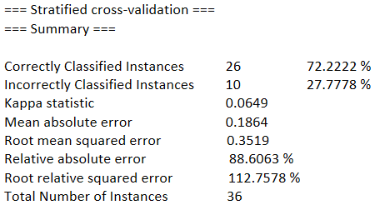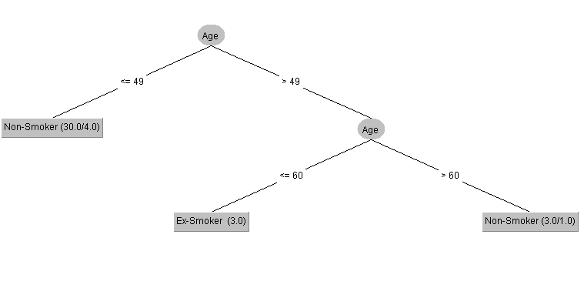

Figure 3.2.2 - J48 Decision tree predicting smoking using all attributes (tree created with age)

Figure 3.2.2 shows the major problem with the Physionet data set. When asked to create a decision tree for the smoking characteristic based on the other attributes including the desired variance attribute, the tree that provided the most accuracy was created using age and still featured 27% error. This is level of prediction is not accurate enough to meet the prediction requirements and while the correlation between age and previous smoking status is interesting, it does not provide any useful aid in predicting current patient conditions as part of our project. For this reason, this tree will be removed from further analysis.

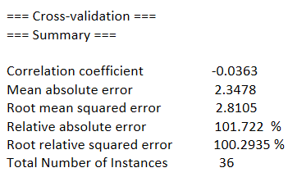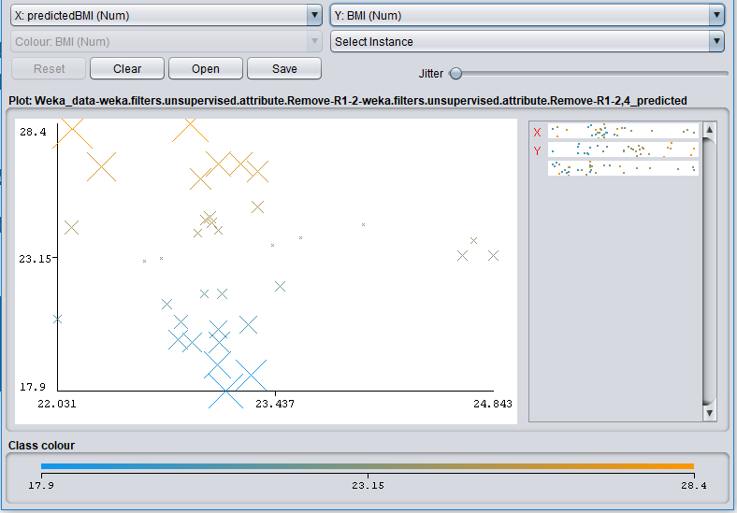

Figure 3.2.3 - Analysis results for simple linear regression predicting BMI with variance

Similarly, we had challenges when predicting other attributes of the data such as BMI. Figure 3.2.3 shows the results from a linear regression analysis predicting BMI using only the variance of SpO2 readings. Outliers within the data set resulted in a few wildly inaccurate predictions with most falling relatively close to their expected range, though nowhere close to the accuracy necessary to make determinations on personal health. A conclusion of the study cited was that resting SpO2 varies across other more immediate factors. Again, using only data from healthy participants held us back from seeing abnormal readings that would make prediction easier.

## Python Results Employing Kaggle

Another is for Python. The group with Weka implemented and used decision trees well; the group with Python did feature engineering and predict the result successfully.

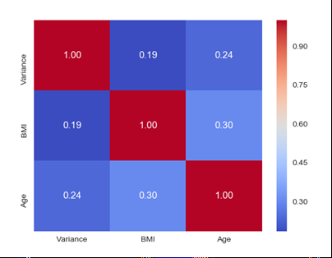

Figure 3.3.1 - Heatmap for relationship between variance and BMI, age with Python

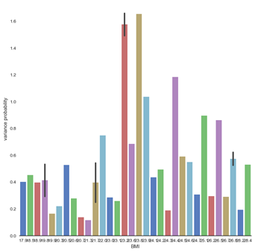 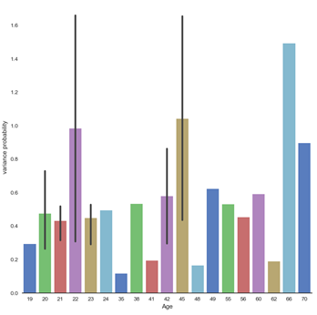

Figure 3.3.2 - BMI vs Variance Figure 3.3.3 - Age vs Variance

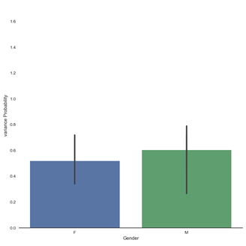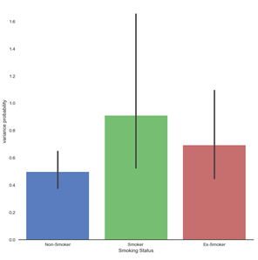

Figure 3.3.4 - Gender vs Variance Figure 3.3.5 - Smoking Status vs Variance

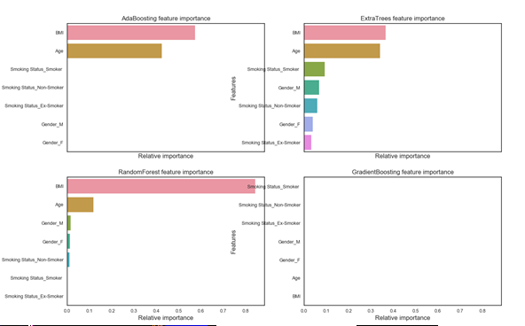

Figure 3.3.6 - Feature importance for the four tree based classifiers

# Economic Analysis

## Materials, Components, and Production Costs

For our prototype we used a raspberry pi 3 as our embedded device with a touch screen. All software used is free and protected by open source licensing. Permission would need to be negotiated with Onkol for the use of their software but it is listed under the licence. The approximate cost of each device is $140 dollars. Table 4.1.1 shows the cost breakdown for each device. The medical devices that would be networked as part of the IoT solution would be designed and sold separately and are therefore not included in the analysis of our system.

|  |  |
| --- | --- |
| Component | Cost |
| Raspberry Pi 3 Hardware | $40 |
| Touch Screen w/ Casing | $100 |
| **Total**: | $140 |

Table 4.1.1 - Component Costs

Production costs are limited to assembly of the purchased hardware components. The embedded system would come pre-assembled with all necessary software installed for the customer. Assembly of the components would be done manually by an employee.

## Development and Maintenance Costs

The development of our prototype was relatively cheap, requiring mostly just work hours. We each worked roughly 10 hours a week on this project. A software engineer would be paid around $40 dollars an hour. This makes the time spent on this project worth approximately $44,800 dollars. We were given a budget of $500 dollars to work with. With this the only purchase we made was a bluetooth low energy sniffer for $34.99, keeping us significantly under our goal.

The software of our product will need updates periodically to ensure continued security and other maintenance concerns. If we assume that our current team will work on the project for 5 hours a week, this would cost $41,600 dollars a year. This does not include further development of the system that could include adding additional device compatibility.

## Total Cost and Sales Forecast

The total cost of the product is broken down in table 4.3.1. This accounts for the theoretical work that we did on the project combined among all 4 workers. The materials and production costs for each unit come to $150 per system.

|  |  |
| --- | --- |
| **Item** | **Cost** |
| Materials | $140 /unit |
| Development | $44,800 /year |
| Maintenance | $41,600 /year |
| Production | $10 /unit |

Table 4.3.1

The medical device market is huge with thousands of hospitals, nursing homes, and other medical facilities. Direct Supply alone serves over 10,000 Senior Living facilities with their supply chain and moves about $3 billion worth of product per year. The team analyzed possible strategies for marketing the product and settled on the following sales forecast: If we sell the product with a profit margin of $50 dollars, the cost for the customer would be $200 dollars. At this price in order to break even on the development cost we would need to sell 896 units. An additional 832 units a year would need to be sold to keep up with the continuing maintenance costs. Direct Supply has a large customer base, and thus we should be able to sell significantly more units and maintain a profit.

# Risk Analysis and Regulatory Information

## Risk Analysis

A major risk to the operation of the Bluetooth hub device is the loss of recorded data. The loss of recorded data would ruin the primary function of this device and inhibit its ability to assist both the patient and caregiver. Additionally, the loss of data of data in a fully implemented version of our system would require the retraining of the machine learning algorithm intended to help our medical caregivers. The loss of data would be a severe detriment to system and as the data would currently be stored on the SD card that houses our device’s operating system, it represents a point of failure. Storing the local data to a more secure disk than an SD card could help reduce the probability. Furthermore, the implementation of a server based data backup system would help mitigate the amount of damage done to by a data loss event.

The FDA requires that medical devices manufacturers must address all risks including cybersecurity risks that may arise before and after FDA approval. Should the development of this project be continued, the development team should prioritize the minimization of cybersecurity risks.

A security concern of the product we developed is the vulnerability of Bluetooth packets. Previous C40 teams backwards engineered a data collection protocol entirely through the usage of a bluetooth sniffer warning that the data packets are unprotected. A malicious user can decipher the information being transmitted from the medical device to the smart hub compromising the security of the IoT solution. Maintaining the privacy of medical information is incredibly important; our team views the security by obscurity approach that many IoT devices as unacceptable in the medical field. While the issue of data security is an incredibly serious one, we also believe that it's unlikely that someone would be interested in the pulse oximeter data our device contains in its current form. Should this project be continued the need for better security will increase as the device interfaces with a larger variety of devices. Applying encryption to the data before it is transmitted over the BLE protocol would greatly improve the security of the device’s BLE transmissions and help mitigate security

## Applicable Standards

Our project was subject to several IEEE and other standards. However, we ran into significant trouble as the lack of standards that affect the Bluetooth Low Energy protocol made interpreting the packets and procedure followed by the pulse oximeter very complicated. The primary standard involved in our project is the Generic Attributes (GATT) profile, a commonly adhered to standard used in BLE to define the client and server relationship. The problem we ran into is that there are many different ways to encapsulate this GATT profile in their own connection protocols. Despite the standard being defined, most BLE devices will require additional knowledge to be able to properly interface with them. Our device does interface with the GATT protocol, however the pulse oximeter we use has a custom protocol that the host device must navigate before it can exchange GATT information.

The Bluetooth Special Interest Group (SiG) has also promoted the usage of the BLE Health Device Profile (HDP). As stated in the HDP spec document, the profile is to be used to connect source data devices such as our pulse oximeters to data sink devices such as our embedded device. [20] Having our device conform to the BLE Health Device Profile would greatly increase the scope of devices it could connect to for future development.

## Regulatory Issues

As this device is intended to be used in a home environment by both healthcare professionals and non-professional users, this device would be classified by the U.S. Food & Drug Administration (FDA) as a Home User Device. As a Home User Device, our product would fall under the general classification of a medical device product, which is regulated by the FDA. [21]

While the 21st Century Cures Act relaxed the regulations on medical device software our device would still probably remain under closer regulation according to the draft guidance document on Clinical and Patient Decision Support software released by the FDA. As the machine learning component of our project contains an undisclosed algorithm intended to assist the decision making of a caregiver. [22]

## Legal Issues

With the passing of the 21st Century Cures Act our device would be subject to the device definition of regulatory provisions for the FDA. As discussed in the Risk Analysis section of this report, the FDA maintains that medical device manufacturers must comply with is that manufacturers must address all risks, this includes cybersecurity risks. These regulations also state that though Healthcare Delivery Organizations are responsible for implementing patches and changes to devices on their networks, medical device manufacturers are responsible for making software changes to address cybersecurity vulnerabilities. [23]

The code and methods that help establish BLE connections that were obtained from Onköl were licensed with the Apache License, Version 2.0. The Apache License contains rules for the redistribution of the code with that license as well as works derivative from that code. One requirement that affects our project is that we are required to give recipients of our code a copy of the Apache License as long as it contains the licensed works or code derivative of the licensed code. [24]

# Project Legacy

## Internet of Things in Home Health Care Applications

The home health care industry is an extremely viable application for the internet of things. Very accurate sensors are becoming inexpensive and easy to use. What once required a full checkup at the doctor's office can now be done at home. Many of these sensors contain built in wireless technology. IoT represents a lot of potential to gather information from these subsystems seamlessly.

## Applying Machine Learning to Home Health

Machine learning represents the single biggests opportunity for development related to this project. The use of automated systems gathering health information expands the possibilities for automated computer analysis made smarter through machine learning.

Blood oxygen and pulse data has significantly more limited applications without additional context. The significant variety of factors that influence readings make applying machine learning a complex challenge that simply cannot rely on time limited pulse oxygen readings alone. The extremely narrow range of healthy readings further limits the data. After studying the effect of several external factors on resting pulse, our team has concluded that interpreting these types of readings provides no benefit and fall within to narrow a range to be properly assessed by a computer to provide any sort of useful and accurate prediction.

Based on our work with the pulse oximeter data, we have concluded that blood oxygen is incredibly static across healthy adult individuals staying between 96-99%. Going forward with the project, we will need to expand the data set we are working with as 36 individuals is to small a study to draw effective conclusions. In many cases the data is to individualized to give the level of accuracy in predictions we need to move forward in predicting symptoms. The attributes in the study are not strongly correlated to SpO2 readings to categorize cases with which to train the learning algorithm. To improve the study we will need to increase the scope of our data to include other useful tags particularly sickness where the variation in SpO2 should be higher than in healthy people.Moving forward with the machine learning portion, we are looking to expand our research to include another study relevant to the home health space.

## Conclusion

# References

[1] “IoT Connected Devices” - Marquette University College of Engineering Senior Design. Courtney Connery, Noel Lopez, Clayton Armbrust, Changyan Liu, Brandon Guerrero, May 2017

[2] "IEEE SA - P2413 - Standard For An Architectural Framework For The Internet Of Things (Iot)". Standards.ieee.org. N.p., 2017. Web. [Accessed: 25- September-2017].

[3] "SmartThings.", SmartThings.com, 2017. [Online]. Available:<https://www.smartthings.com/>. [Accessed: 25- September-2017].

[4] “Direct Supply”, directsupply.com, 2017 [online] [Accessed: 25- September-2017].

[5] Martin, T. (2017). How to setup Bluetooth on a Raspberry Pi 3. [online] CNET. Available at:<https://www.cnet.com/how-to/how-to-setup-bluetooth-on-a-raspberry-pi-3/> [Accessed 25 Oct. 2017].

[6] Principles of Design 4920, Marquette University, ISBN: 11211939805

[7] "Lifehub System", Biodata Devices, 2017. [Online]. Available:<http://www.biodatadevices.com/index.php?option=com_content&view=article&id=54&Itemid=231&lang=en>. [Accessed: 23- Oct- 2017].

[8] Y. Benabbas, "Getting started with Bluetooth Low Energy on iOS – Yassine benabbas – Medium", Medium, 2017. [Online]. Available:<https://medium.com/@yostane/getting-started-with-bluetooth-low-energy-on-ios-ada3090fc9cc>. [Accessed: 4- Dec- 2017].

[9] "RPi Bluetooth LE - eLinux.org", Elinux.org, 2017. [Online]. Available:<https://www.elinux.org/RPi_Bluetooth_LE>. [Accessed: 4- Dec- 2017].

[10]"VNC (Virtual Network Computing) - Raspberry Pi Documentation", Raspberrypi.org, 2017. [Online]. Available:<https://www.raspberrypi.org/documentation/remote-access/vnc/>. [Accessed: 11- Dec- 2017].

[11]"PaulCreaser/Gatttool-Scripts", GitHub, 2017. [Online]. Available:<https://github.com/PaulCreaser/Gatttool-Scripts>. [Accessed: 4- Dec- 2017].

[12]"Tutorials - Nordic Developer Zone", Devzone.nordicsemi.com, 2017. [Online]. Available:<https://devzone.nordicsemi.com/tutorials/8/>. [Accessed: 4- Dec- 2017].

[13] Amar S. Bhogal and Ali R. Mani. Pattern Analysis of Oxygen Saturation Variability in Healthy Individuals: Entropy of Pulse Oximetry Signals Carries Information about Mean Oxygen Saturation. Frontiers in Physiology, 8, 555. DOI:10.3389/fphys.2017.00555.[bib]

[14] Goldberger AL, Amaral LAN, Glass L, Hausdorff JM, Ivanov PCh, Mark RG, Mietus JE, Moody GB, Peng C-K, Stanley HE. PhysioBank, PhysioToolkit, and PhysioNet: Components of a New Research Resource for Complex Physiologic Signals. Circulation 101(23):e215-e220 [Circulation Electronic Pages; <http://circ.ahajournals.org/content/101/23/e215>]; 2000 (June 13).

[15] Eibe Frank, Mark A. Hall, and Ian H. Witten (2016). The WEKA Workbench. Online Appendix for "Data Mining: Practical Machine Learning Tools and Techniques", Morgan Kaufmann, Fourth Edition, 2016

[16] How To Raspberry Pi. (2018). Install Android on his Raspberry Pi. [online] Available at:<https://howtoraspberrypi.com/install-android-raspberry-pi/> [Accessed 11 Apr. 2018].

[17] Pattern Analysis of Oxygen Saturation Variability (osv). [Online]. Available:<https://physionet.org/physiobank/database/osv/>. [Accessed: 03-May-2018].

[18] “Running Android on a Raspberry Pi 3 - The MagPi Magazine,” Raspberry Pi, 04-Apr-2018. [Online]. Available:<https://www.raspberrypi.org/magpi/android-raspberry-pi/>. [Accessed: 03-May-2018].

[19] “Weka 3: Data Mining Software in Java,” Machine Learning Project at the University of Waikato in New Zealand. [Online]. Available:<https://www.cs.waikato.ac.nz/ml/weka/>. [Accessed: 03-May-2018].

[20] Bluetooth SIG - Medical Devices WG, “Health Device Profile,” Bluetooth SIG, tech., Jul. 2012.

[21] Food and Drug Administration and Center for Devices and Radiological Health, Medical Device Home Use Initiative. 2012.

[22] Food and Drug Administration, Center for Devices and Radiological Health, Center for Biologics Evaluation and Research, and Center for Drug Evaluation and Research, Clinical and Patient Decision Support Software - Draft Guidance for Industry and Food and Drug Administration Staff. 2017.

[23] Center for Devices and Radiological Health, “Digital Health - Cybersecurity,” U S Food and Drug Administration Home Page. [Online]. Available: <https://www.fda.gov/MedicalDevices/DigitalHealth/ucm373213.htm>.

[24] “Apache License, Version 2.0,” Jan-2004. [Online]. Available: <http://www.apache.org/licenses/LICENSE-2.0>.

# Appendices

## Patterns of Oxygen Variability Study Data (Physionet Data)

|  |  |  |  |  |  |  |
| --- | --- | --- | --- | --- | --- | --- |
| **Participant No** | **Record Name** | **Gender** | **Smoking Status** | **BMI** | **Age** | **Variance** |
| 31 | 210217C | F | Non-Smoker | 18.9 | 21 | 0.398301 |
| 28 | 160217E | F | Non-Smoker | 19.8 | 38 | 0.534009 |
| 19 | 070217A | F | Non-Smoker | 19.8 | 19 | 0.292874 |
| 36 | 150317B | M | Non-Smoker | 19.9 | 48 | 0.164165 |
| 15 | 300117A | F | Non-Smoker | 20.3 | 20 | 0.22096 |
| 16 | 010217A | F | Non-Smoker | 20.5 | 23 | 0.527195 |
| 8 | 121216A | M | Non-Smoker | 20.6 | 20 | 0.277889 |
| 21 | 080217B | F | Non-Smoker | 20.7 | 20 | 0.13915 |
| 12 | 250117A | F | Non-Smoker | 21.3 | 35 | 0.117358 |
| 17 | 010217B | F | Non-Smoker | 21.7 | 21 | 0.542964 |
| 1 | 301116B | M | Non-Smoker | 21.7 | 20 | 0.250436 |
| 3 | 051216A | M | Non-Smoker | 22 | 20 | 0.747731 |
| 13 | 250117B | M | Non-Smoker | 23 | 20 | 0.286489 |
| 9 | 121216B | F | Non-Smoker | 23.1 | 21 | 0.258683 |
| 7 | 101216C | M | Non-Smoker | 23.2 | 22 | 1.659468 |
| 4 | 081216A | M | Non-Smoker | 23.6 | 20 | 0.685791 |
| 27 | 160217D | M | Non-Smoker | 23.9 | 45 | 1.036612 |
| 5 | 101216A | F | Non-Smoker | 24.1 | 45 | 0.436644 |
| 26 | 160217C | F | Non-Smoker | 24.2 | 24 | 0.493535 |
| 35 | 150317A | F | Non-Smoker | 24.3 | 62 | 0.189763 |
| 23 | 090217B | F | Non-Smoker | 24.4 | 20 | 1.185177 |
| 20 | 080217A | F | Non-Smoker | 24.7 | 22 | 0.30671 |
| 33 | 010317B | M | Non-Smoker | 25.1 | 70 | 0.895919 |
| 34 | 140317A | M | Non-Smoker | 26.2 | 42 | 0.294879 |
| 2 | 301116A | M | Non-Smoker | 26.5 | 42 | 0.862383 |
| 30 | 210217B | M | Non-Smoker | 26.7 | 23 | 0.291964 |
| 6 | 101216B | M | Non-Smoker | 26.8 | 49 | 0.62296 |
| 22 | 090217A | F | Non-Smoker | 28.2 | 41 | 0.19311 |